Группа 41
Дистант на 08 сентября
Иностранный язык в профессиональной деятельности

Практическое занятие 1. Система образования в России, Великобритании и США.
Education System in the USA, the UK and Russia.
Study the following slides and fill in the table.
Изучите картинки и заполните сводную сравнительную таблицу:
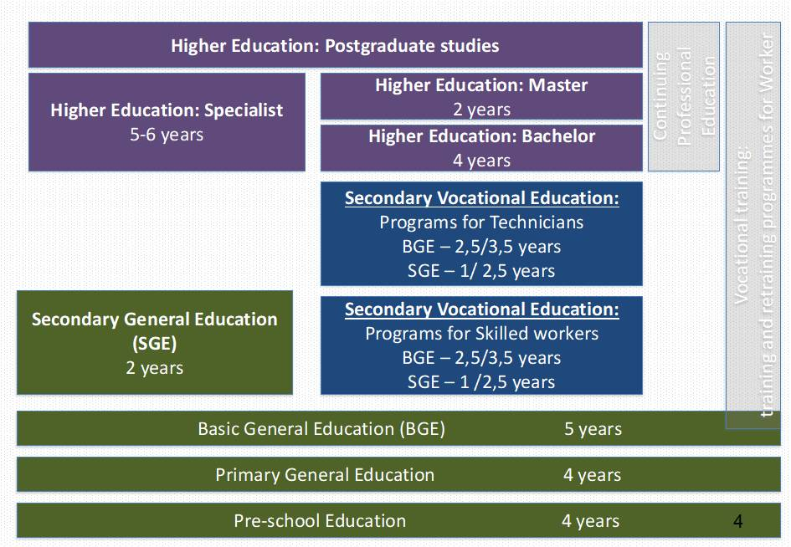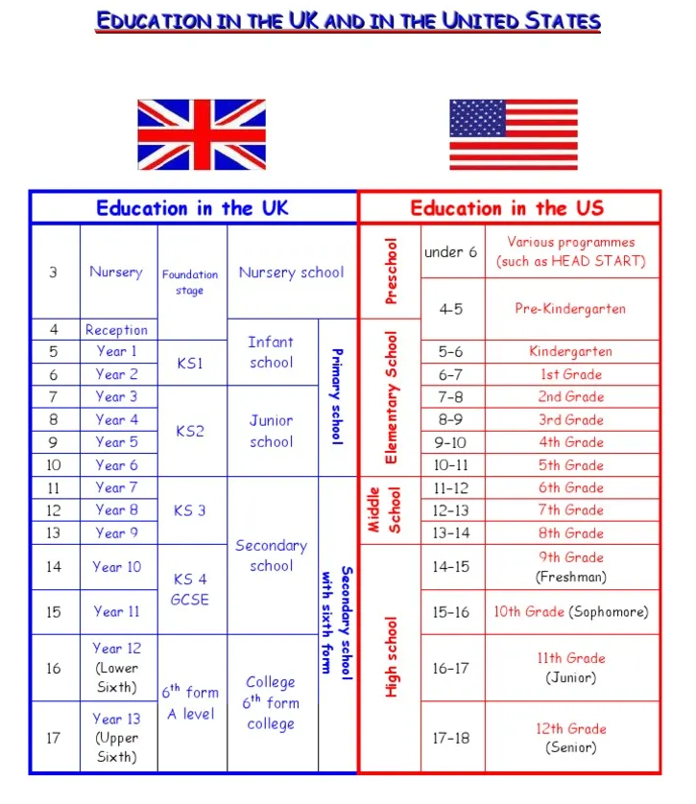

 | RUSSIA | THE UK | THE USA
- When the children go to school for the first time (AGE)
2. Name of first school
3. Name of the school before college
4. Name or stages of higher education
5. Total years in school
2. Read the text and find the words:
Гений -
Переменный ток -
Постоянный ток -
Метод проб и ошибок -

Tesla and the War of the Currents
Today, most people recognize the name Tesla as a company that makes electric vehicles, but the real genius behind the name is not Elon Musk—it’s the Serbian-American engineer and physicist Nikola Tesla. Tesla, for all intents and purposes, was the man who pioneered today’s modern alternating-current (AC) electricity supply system.
Tesla was born in 1856 in Smiljan, Croatia, which was part of the Austro-Hungarian Empire at the time. He studied math and physics at the Technical University of Graz in Austria, and also studied philosophy for a time at the University of Prague in what is now the Czech Republic. In 1882, he moved to Paris and got a job repairing direct-current (DC) power plants with the Continental Edison Co. Two years later, he immigrated to the U.S., where he became a naturalized citizen in 1889.
Upon arrival in the U.S., Tesla found a job working for Thomas Edison in New York City, which he did for about a year. Edison was reportedly impressed by Tesla’s skill and work ethic, but the two men were much different in their methods and temperament. Tesla solved many problems through visionary revelations; whereas, Edison relied more on practical experiments and trial-and-error. Furthermore, Tesla believed strongly that AC electrical systems were more practical for large-scale power delivery; whereas, Edison championed DC systems in what has since come to be known as the “War of the Currents.”
Tesla left Edison’s company following a payment dispute over one of Tesla’s dynamo improvements. After his departure, Tesla struggled for a time to find funding to start his own business. When he finally did get his company going, Tesla moved quickly, and over the span of about two years he was granted more than 30 patents for his inventions, which included a whole polyphase system of AC dynamos, transformers, and motors.
Word of Tesla’s innovative ideas spread, leading to an invitation for him to speak before the American Institute of Electrical Engineers. It was here that Tesla caught the eye of George Westinghouse, another AC power pioneer. Soon thereafter, Westinghouse bought the rights to Tesla’s patents and momentum for AC systems picked up.
Тетради сдаем на следующей паре.
Thank you very much!

