49 группа
30 марта 2023 года
Все выполненные работы сдаем на уроке или фотографируем и отправляем на kan@apt29.ru.
Практическое занятие № 56 «Составление диалога по теме «Магазины, покупки».
SHOPPING
Vocabulary
a foodstuff - продукт (пищевой) a food store - продуктовый магазин
in quantities- в большом количестве to load – загружать a luggage compartment - багажник автомобиля spacious – просторный a shop window – витрина dairy produce- молочная продукция
a grocery- бакалея fowl- дичь bakery goods - хлебо-булочные изделия a confectionery- кондитерский отдел a ring- бублик, баранка garlic- чеснок
curds – творог margarine - маргарин
mayonnaise – майонез a rusk- сухарь flour – мука groats- крупа spice- спeции , пряность granulated sugar - сахарный песок instant- моментальный, здесь : растворимый attractive- привлекательный
frozen fish - мороженая рыба smoked fish - копченая рыба
a shrimp- креветка crawfish- рак (речной, морской)
a lobster- омар an oyster- устрица
tinned fish- рыбные консервы a greengrocery- отдел" Овощи -фрукты"
irrespective of smth. - независимо от чего-либо a pear - груша
a tangerine- мандарин an apricot- абрикос
a peach – персик grapes- виноград
a berry – ягода strawberry – клубника
raspberry – малина cherry - вишня
cranberry- клюква red bilberry - брусника
carrot- морковь a cucumber - огурец
cabbage-капуста beetroot- свекла
onion – лук a crab - краб
a cashier- кассир
an expiry date- дата истечения срока (хранения)
to be well stocked with smth.- иметь в продаже широкий ассортимент
to be at one's disposal- быть в чьем-либо распоряжении
to provide oneself with smth. - обеспечивать себя ч.-л.
SHOPPING (AT THE SUPERMARKET)
People buy foodstuffs at the food stores, at the markets and at the supermarkets. It is more convenient to do shopping at the supermarket: you can find there everything you need. More and more people nowadays prefer to provide themselves with foodstuffs for a long period. As they buy in quantities, they go to the supermarket by car and after having done shopping they load their bags and packets into the luggage compartment.
Let us visit one of the supermarkets in the city. It is a one-storied building, spacious and light, with large shop windows. Inside we can see some signs: Dairy produce, Dry groceries, Vegetables and Fruit, Meat and Fowl, Fish, Bakery Goods, Confectionery and Pastry, Wine. The dairy produce counter is well stocked with fresh milk foodstuffs. What is there for sale? Butter, cheese, curds, cream, sour cream, milk, fruit yoghurt, eggs, margarine, mayonnaise.
Everything is sold ready packed. Next to this is the bakery counter where everybody can choose whatever he or she likes: white and brown bread, buns, rolls, rings, pies, cheese cakes and so on.
In the dry groceries counter there is also a great choice of produce. You can buy flour, spice, tea, sugar (lump, cube, granulated) there. Besides, customers can find there various packets filled with dry soup, noodles or chips. They are easy to cook within three minutes.
The meat and fowl counter looks very attractive too. Chicken, ham, pork, bacon, beef, veal and mutton are at your disposal there. You will find a variety of sausages in this section too. A special counter handles frozen and fresh fish; smoked and dry fish is also offered to the customers. Besides, the counter is full of sea products, quite exotic and unseen before. There are crabs, shrimps, crawfish, lobsters, oysters. A large space is occupied with tinned fish.
The section where fruit and vegetables are for sale is called a greengrocery. It always attracts a lot of customers because irrespective of the season the counters are full of fresh fruit and vegetables grown in Russia or brought from other countries. Apples and pears, oranges, lemons and tangerines, apricots and peaches, bananas and grapes are practically available all the year round. For those who like berries there are strawberries, raspberries, cherries, cranberries and red bilberries nicely packed in small baskets. If you want to buy vegetables, you will find everything you need: potatoes, carrots, cucumbers, tomatoes, cabbage, beetroot, onion, garlic.
When doing shopping at the supermarket don't forget to look at the expiry date printed on the packet. You are recommended to use the foodstuff before it.
Choosing products customers put them into a special basket and with the basket full go to the cashier. The cashier calls the price and gives them a check.
Visiting a supermarket you considerably save your time.
Exercise I
Answer the questions:
1. What is the most popular supermarket in your district? What counters look attractive there?
2. How often do you visit the supermarket? Do you buy in quantities? Do you go there by car?
3. Do you always look at the expiry date when buying dairy or meat foodstuffs?
4. What produce do you buy if you want to cook a holiday dinner?
5. Do you like exotic foodstuffs? Which of them did you have to buy?
6. Is the price for foodstuffs at the supermarket higher than that in small shops or in the markets?
7. How much do you spend for foodstuffs a week? Can you afford to buy in quantities?
REMEMBER!
We buy:
bread at a bakery (at a baker's)
vegetables and fruit at a greengrocery (at a greengrocer's)
flour and groats at a grocery (at a grocer's)
meat at a butcher's
fish at a fishmongery (at a fishmonger's)
butter and milk at a dairy
Exercise II
Name as many things as possible that you can buy:
at the dairy at the bakery
at the fishmongery at the grocery
at the greengrocery at the butcher's
Use the model: At the________ one can buy or
The following things are for sale at the____________
Exercise III
Say to what counter of the supermarket you go if you want to buy:
granulated sugar, tea, and spice
cheese, sour cream, and butter
chicken, turkey, and frankfurters
trout, shrimps, and caviar
a pastry, a bun, and a cake
a bottle of brandy, a tin of beer, and a bottle of champagne
veal, ham, and beef
eggs, margarine, and mayonnaise
herring, tinned fish, and cod

Use the model: If I need , I go to the
Exercise IV
Translate into English:
1. Мне нужно полфунта сухарей. Сколько они стоят?
2.Я куплю баранину, если она не очень жирная, немного ветчины и сосисок.
3.В рыбном отделе можно купить свежую и замороженную рыбу; там также продается икра и рыбные консервы.
4.- Где можно купить специи? - В том же отделе, где продается мука и крупа.
5.У вас есть в продаже сметана и творог? Когда истекает их срок хранения?
6.Цены на овощи в этом магазине вполне приемлемые, а вот фрукты стоят дорого.
7.Дайте мне, пожалуйста, полкило копченой рыбы, килограмм свежей трески и баночку красной икры.
8.По дороге домой мне нужно зайти в универсам и купить пачку индийского чая, растворимый кофе и буханку белого и черного хлеба.
9.В этом магазине большой выбор сухих вин из Франции и Испании.
10.В этом универсаме продаются экзотические фрукты и овощи. Вы найдете их в шестом
ряду.

Практическое занятие № 57 «Особенности придаточных предложений времени в английском языке».
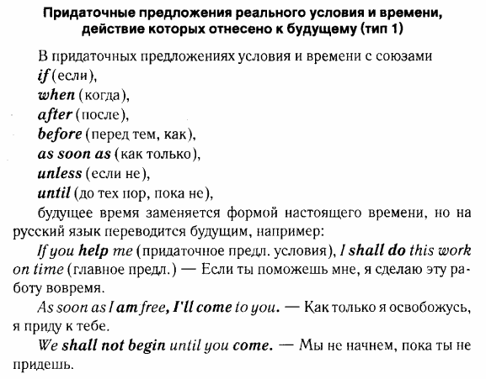
Выберите в скобках верный вариант союза времени. Переведите предложения.
- Please, call me ... (while/as soon as/till) you arrive at the station.
- ... (Until/After/Before) going to sleep, she likes reading a book for an hour or so.
- Don’t sit down ... (until/after/while) we ask you.
- The house became empty ... (after/before/until) they left.
- I won’t start my journey ... (when/while/until) he pays all my expenses.
- ... (As soon as/While/Before) he was making a fire, it started raining.
- ... (While/Till/As soon as) we get married, we’ll move to another place.
- Turn off the light ... (before/when/while) the lesson is over.
- You should read this paper ... (before/until/while) you express your opinion.
- We won’t start our dinner ... (after/until/as soon as) Richard arrives.

