Дистант для 12 группы
07.03.2023
Иностранный язык
ВСЕ ВЫПОЛНЕННЫЕ ЗАДАНИЯ ОТПРАВЛЯЕМ НА KAN@APT29.RU
Лексический минимум для чтения и перевода англоязычных текстов по теме: «Погода, прогноз погоды, осадки».

Задание 1. Выписать термины слева в тетрадь, догадаться о значении его из объяснения справа.

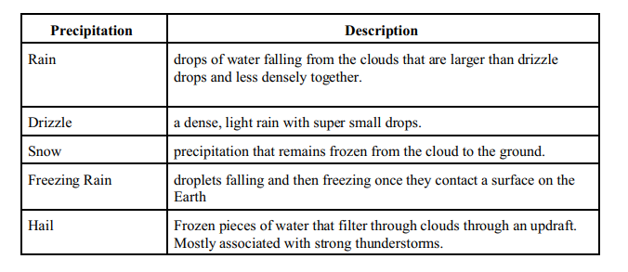
Задание 2. Выбрать правильный ответ:
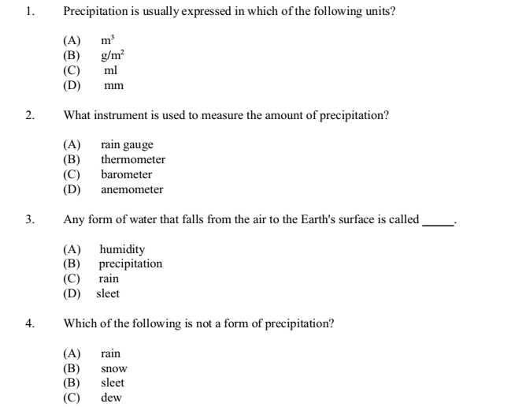
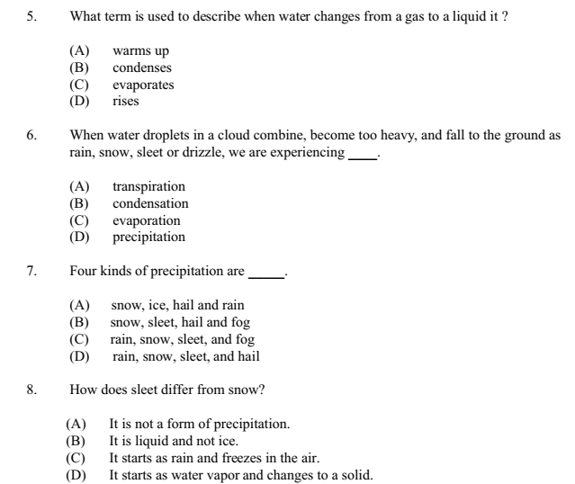
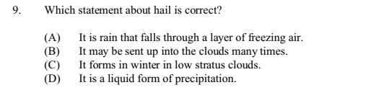
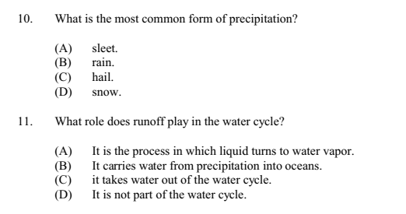

Задание 3. Заполнить пропуски словами:
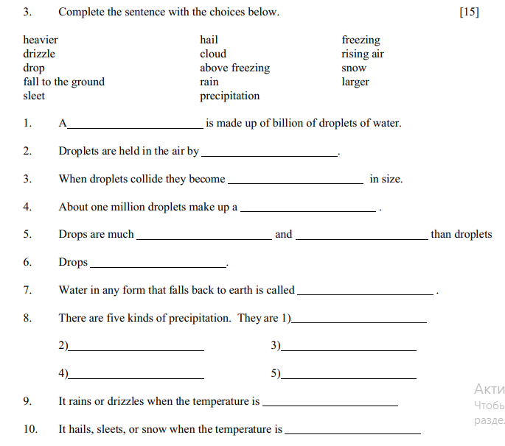

Практическое занятие № 27. «Изучение правильных и неправильных глаголов».
Тренировочные упражнения:
1. Write the past form (Past Simple) of these verbs:

To study – studied
To think – thought
To begin –
To find –
To have –
To be –
To see –
To come –
To write –
To copy –
To sign –
To fix –
2. Write the Participle II of these verbs:

To think – thought
To run – run
To drink –
To know –
To make –
To eat –
To hear –
To go –
To blink -
To pay –
To collect –
To write -

3. Make questions to the sentences.
1. Mike went to England a month ago.
a) Who? b) Where?
2. The boys played games out of doors last Sunday.
a) Who? b) When?
3. The children stayed at the seaside for two weeks a year ago.
a) Where? b) When?

4. Найдите в тексте 2-ую и 3-ю формы неправильных глаголов и распределите их в соответствующие колонки.
II форма III форма
…… ……

Chris is a professional artist. He fell in love with drawing when he was 3 years old. He spent all days long in the garden with a box of crayons and a drawing-pad. Now he has already sold more than 200 of his paintings. He has taken part in the International exhibition of modern artists this year and has won praise as the youngest artist there. Two years ago Chris met a nice girl, Anna. So last Saturday they got married and today they have flown to the Maldives.

