Дистант для 49 группы 1 курса 17.01.23
Работа, поиск работы. Searching for a Job.
Задание 1. Спишите слова слева, переведите их и вставьте в предложения. Можно вставить цифру предложения и слово, предложения не списывать, а перевести на русский язык.
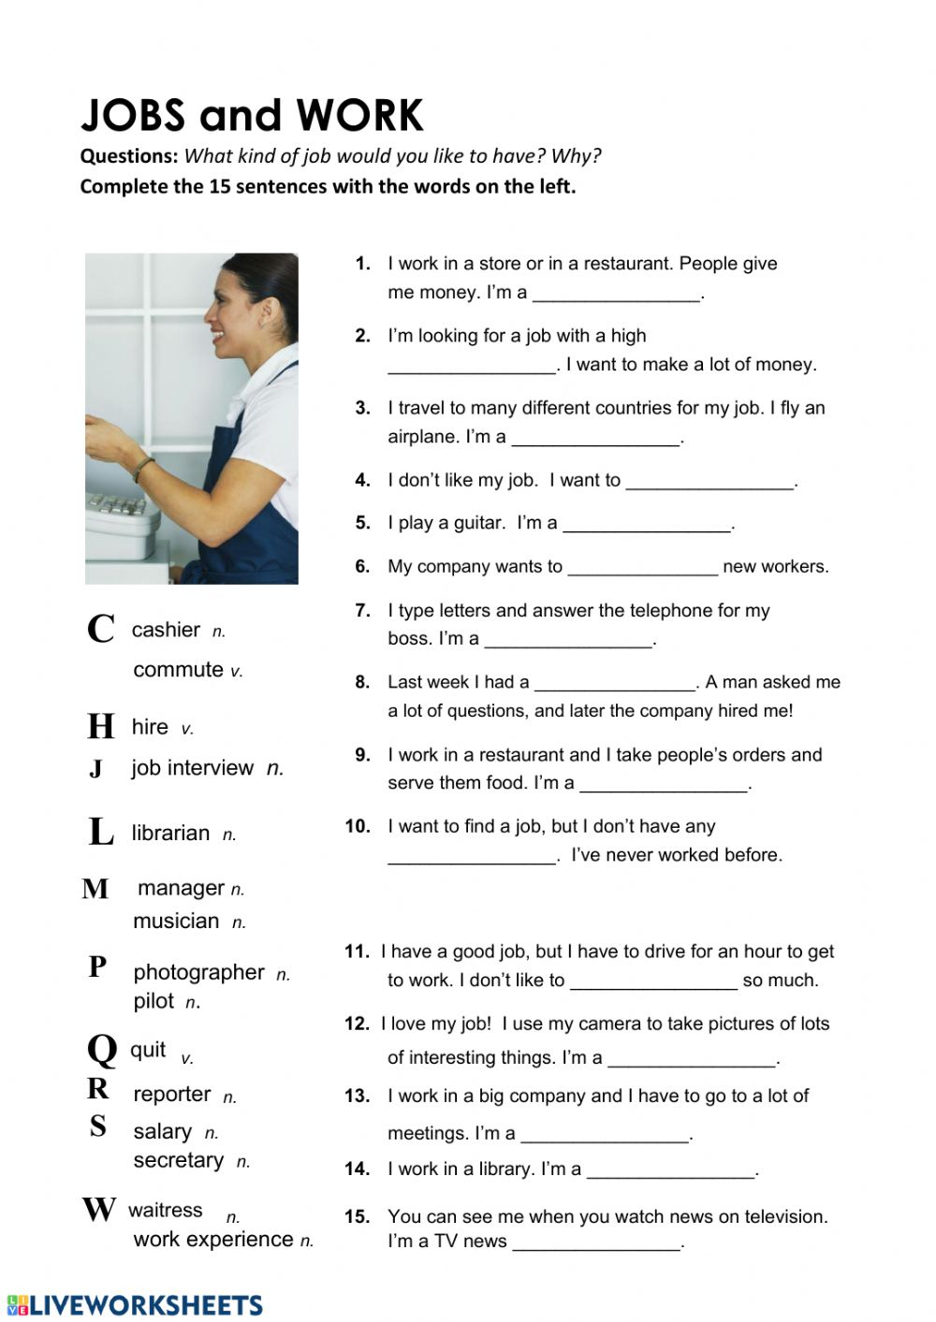

Задание 2. Поставьте глаголы в скобках в Present Simple, Past Simple, Future Simple, Present Continuous, Past Continuous, Future Continuous.
- I (to go) to the cinema when you met me.
- I (to do) my homework when mother came home.
- I (to do) my homework yesterday.
- They (to read) many books every week.
- I (to do) my homework the whole evening yesterday.
- They (to read) many books tomorrow?
- They (not to read) many books this time yesterday.
- The children (to eat) a cake tomorrow?
- The children (not to eat) soup now.
- When you (to play) volley-ball yesterday?
- We (not to dance) every day.
- Look! Kate (to dance).
- Kate (to sing) well?
- Where John (to live)? - - He (to live) in England.
- I (to go) to the cinema yesterday.
- I (to go) to the cinema at four o'clock yesterday.
- I (to do) my homework from five till eight tomorrow.
- The children (to eat) carrots now?
- I (to do) my homework at six o'clock yesterday.
- They (to go) to the cinema tomorrow?
- Mary(not to do) her homework tomorrow.

Тетради сдаем на паре
Good luck!

