Дистант для группы 41 1 курс 17.01.23
Работа, поиск работы. Searching for a Job.
Задание 1. Спишите слова слева, переведите их и вставьте в предложения. Можно вставить цифру предложения и слово, предложения не списывать, а перевести на русский язык.
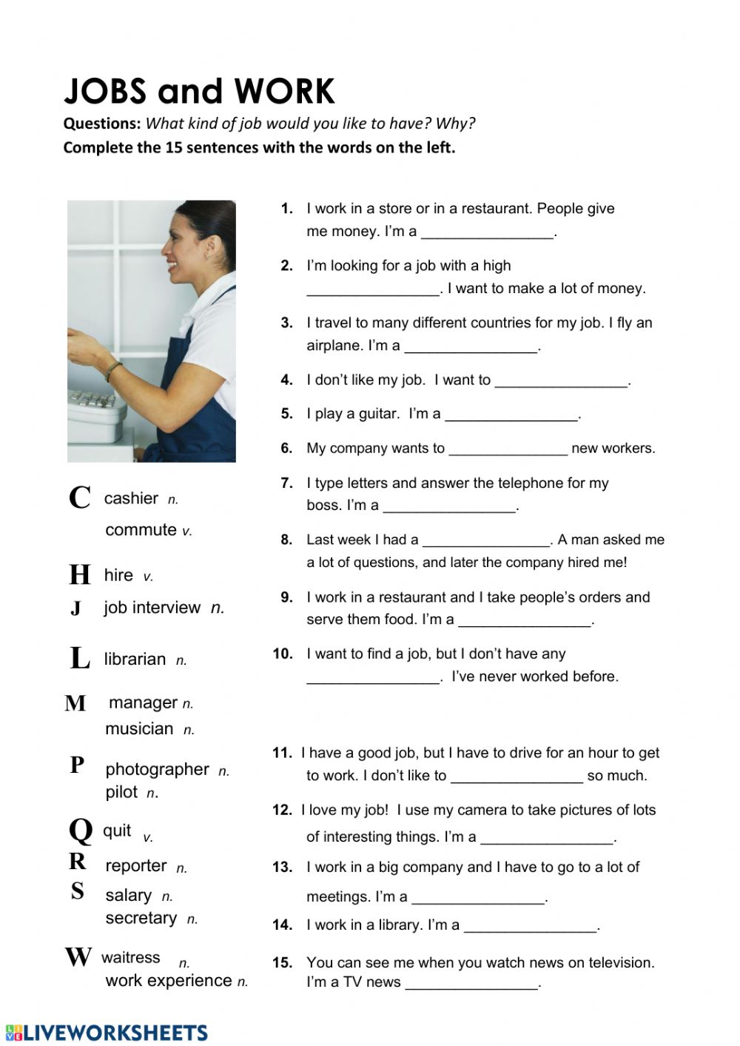

Задание 2. Поставьте глаголы в скобках в Present Continuous:
- Alice and Ron … (to sit) in a cafe now.
- It … (not to snow) outdoors now.
- We … (to wait) for our teacher in the classroom.
- I … (to watch) the children playing in the yard.
- The girls … (to argue) about what present to buy for Lewis.
- Andrew … (not to have) a rest at the moment.
- Look! All the people … (to come) into the hall.
- Unfortunately our experiment… (not to go) according to the plan.
- Pam … (to stand) too close to the road.
- The students … (not to have) a lecture now.
- Her health … (to improve) day after day.
- The rainforests … (to disappear) from our planet nowadays.
- The baby-sitter … (not to look) after the child because the child … (to sleep) now.
- Look! The guide … (to point) at some ancient building.
- I… (not to discuss) this question now.

Тетради сдаем на паре
Good luck!

