- Прочтите теорию и выполните в рабочей тетради задания:
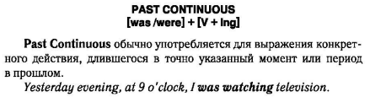
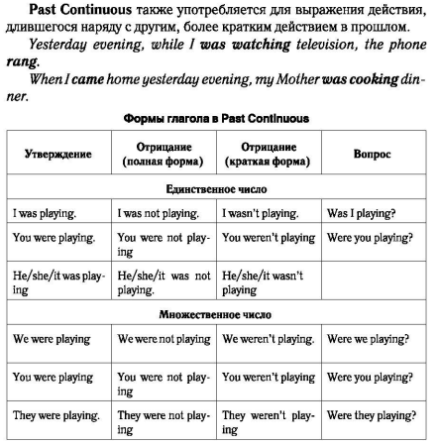

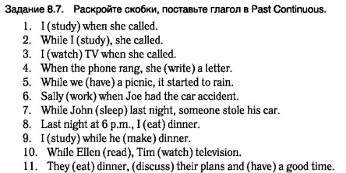
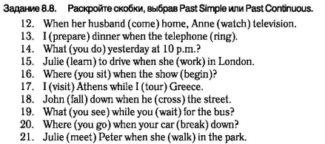

- Прочтите текст. Выпишите несколько (минимум 10) незнакомых для себя слов.

I have always wanted to spend more time in the countryside. My family and I live in the suburbs of a big city. My grandparents live in the village not far from us. We often visit them and in summer time I can stay there for a month or two.
I enjoy being in the countryside more than in the city. My grandparents own a small country house at the edge of the forest. There is a spacious garden and a chicken coop behind the house. Life in the city is boring for me. It consists of school and several friends. Whereas in the country I can swim in the local lake, pick berries and mushrooms, help my grandparents with the garden, go for a walk in the woods, read a book under the shed, go camping with friends and do many other interesting activities.

I think that life in the village is fantastic! I really enjoy spending my weekends and holidays there. If I grow up I’d like to have a house in the countryside instead of a city flat. I prefer old-fashioned, wooden houses with traditional Russian ornaments in it. I’d like to plant many fruit trees and colourful flowers around my house. If there is a river or a pond nearby, it would be perfect. I like swimming and sunbathing in summer. To make my life complete there, I need some pets. Most of all I like cats and dogs but I can also keep a dozen of chickens in the village. They will supply me with fresh eggs every day.
The best thing about living in the countryside is the fresh air and relaxing atmosphere.

