- Прочитайте:
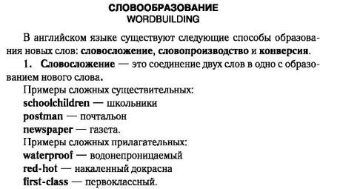
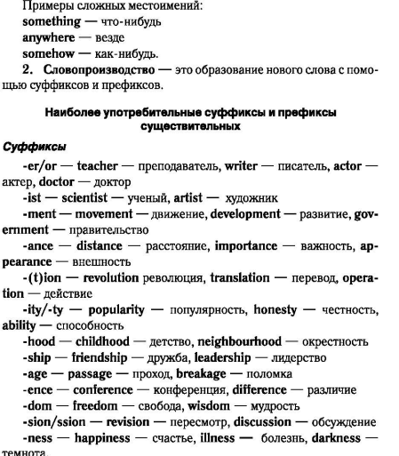

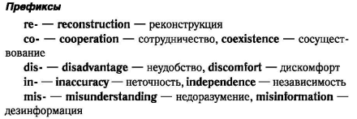
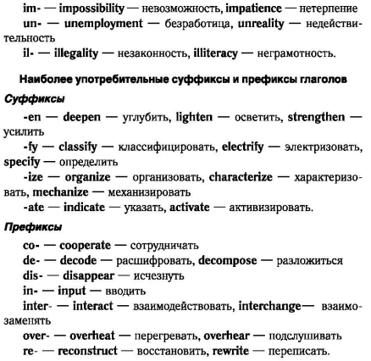
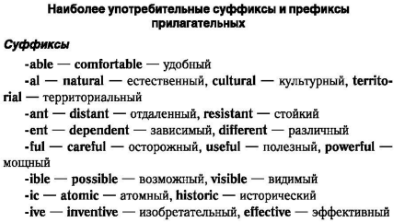
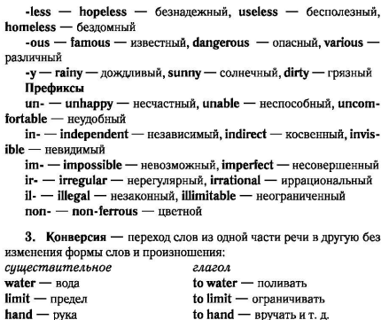

- Выполните задания в рабочей тетради:
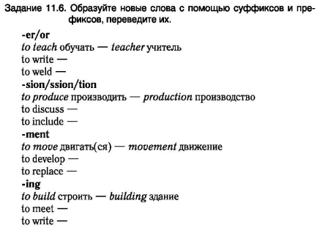
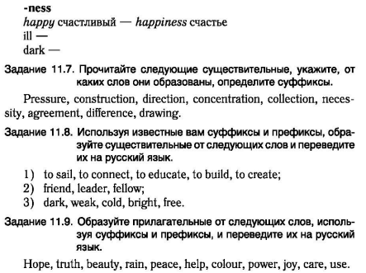

- Прочтите текст, выпишите незнакомые для себя слова

All professions are interesting to me and every profession has advantages and disadvantages. But there is one profession that I love so much even if there are some minuses. In future I would like to become a cook.
I like to cook a lot. I have no cooks in my family but my mom and my granny know many recipes and they cook very well. When we have guests they always cook something delicious and I learn all these recipes. Few months ago I started to cook by myself. I like to cook salads and soups, cookies and cakes. Sometime I need help but basically I do everything alone. My friends like to come and they always say that I am a good cook.
Cooking makes me happier. When I cook I feel I am doing something useful and interesting. I like to mix ingredients and to try new recipes. I hope in future to become a good and famous cook. My favorite dish to cook is a cake. I cook them often for my dad. He likes a lot cakes with fruit and berries.
So I could work in a restaurant and to cook new dishes. People would come only because they knew that food here is great. I think it’s a dream of any cook,
In general it’s not difficult to study. You just have to be attentive and to follow your heart. My granny says that you have to cook with your heart if you want to have a delicious dish. So I am ready to do my best.
Also a good cook has to know all the products and has to understand how to mix them. It’s good if you like to watch tv programmes about cooking. They are also experience and some advice.
In general any good profession requires time, patience and love. If you like to cook all your food will be tasty and dishes will be nice. You will always have full house of friends and your kitchen will be your favorite room. But I can also understand people who don’t want or don’t like cooking. Tastes differ. For me every product is something special, something that has different form, color, taste. I think I was born to be a cook and of course thanks to my mom and my granny I have learnt many tricks and secrets.

