Дистант для группы 43
18.04.2022
Выполненные работы присылаем на kan@apt29.ru
Практическое занятие 76. Изучение отрицательных местоимений.
Запишите таблицы в тетрадь, выполните упражнение:
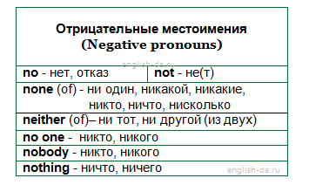
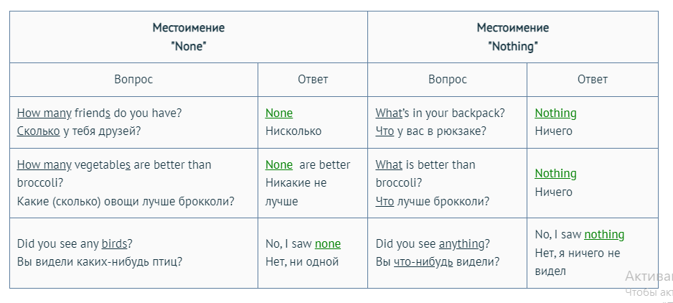
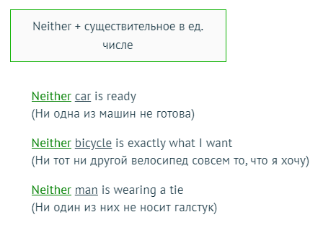
Вставьте отрицательные местоимения в пропуски:
- ______is going to find out your secret.
- I have two computers, but ______of them work.
- ______of them answered the question.
- The police did ______to stop the thief.
- I have ______news to tell you.
- ______of us went to the cinema yesterday.
- I called her, but ______replied.
- Sara liked ______of the songs.
- ______told me that we were going to meet on Sunday.
- Steve had ______to laugh at.

Практическое занятие 77. Употребление возвратных местоимений в устной и письменной речи.
Списать таблицу в тетрадь, выполнить Упр. 1.
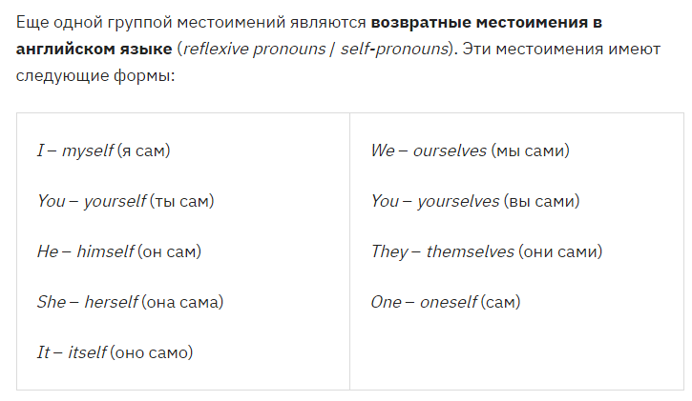
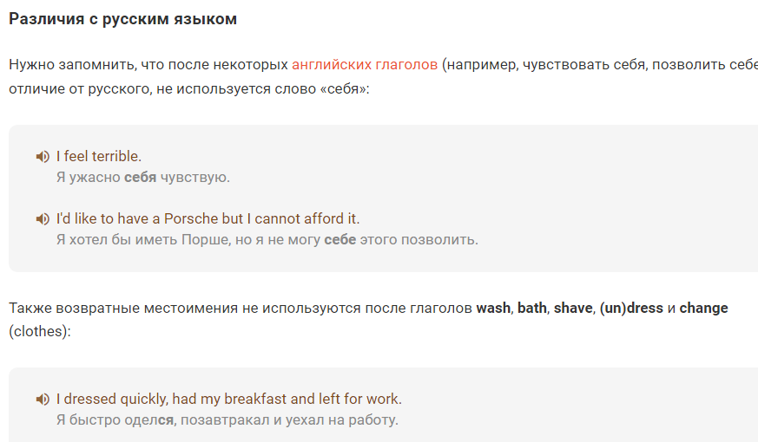
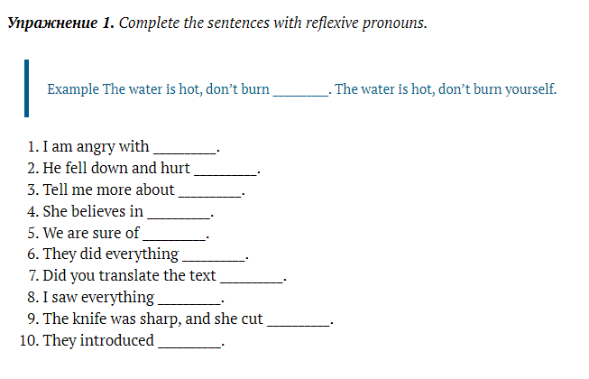

Государственное устройство Великобритании.
Перевести письменно текст в тетради:

Political System of Great Britain
The United Kingdom of Great Britain and Northern Ireland is a constitutional monarchy.
The power of Queen Elizabeth II is not absolute. It is limited by Parliament. The legislative body, Parliament, consists of two chambers: the House of Lords and the House of Commons.
The executive body consists of the central Government — that is the Prime Minister and the Cabinet of Ministers, who are responsible for initiating and directing the national policy.
The judiciary body is independent of both the legislative and the executive ones.
The Government derives its authority from the elected House of Commons. General elections, for all seats in the House of Commons, must be held at least every five years. The Government is normally formed by the political party which is supported by the majority in the House of Commons. The leader of the party is appointed the Prime Minister by the Queen and chooses a team of ministers. The second largest party becomes the Official Opposition with its own leader and the “Shadow Cabinet”.
The House of Lords is a hereditary chamber.
In Great Britain there is no written constitution, only customs and traditions.

