Задание на 2 июня.
In on between under in front of
Behind on the right of on the left of
Выполнить 2 июня к 16.00
Вспомнить предлоги места, посмотреть на
картинки и вставить нужные предлоги
Prepositions of place
Where’s
the dog ?
Where’s the cat ?

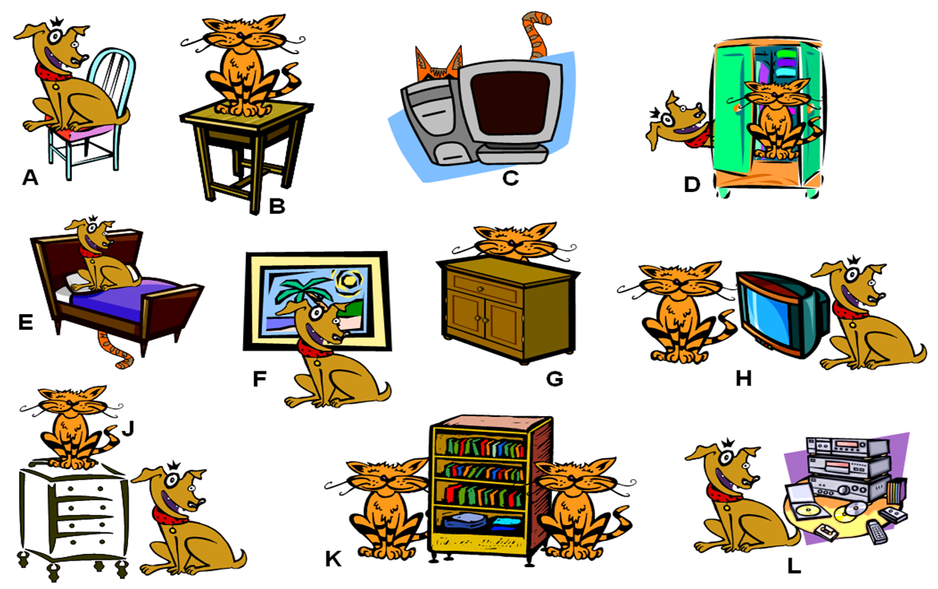

A –The dog is .......................... the chair. K – There is a cat ............................... the bookcase
B – The cat is .......................... the table. and another cat ............................ the bookcase.
C – The cat is ......................... the computer. The bookcase is ............................. the two cats.
D – The dog is .......................... the wardrobe. L –The dog is ................................ the CD system.
The cat is .............................. the wardrobe.
E – The dog is .............................. the bed.
The cat is .............................. the bed.
F – The dog is ............................. the picture.
G – The cat is .............................. the cupboard.
H – The cat is .............................. the TV.
The dog is ................................ the TV.
The TV is .............................. the cat and the dog.
J – The dog is ............................ the chest of drawers.
The cat is ............................ the chest of drawers.

