Ответы можно присылать на почту panteleyeva88@yandex.ru или личными сообщениями в вк

В названии файла или перед выполненным упражнением указывайте номер группы и свою фамилию

Изучите глоссарий по теме «Государственное и политическое устройство России» * и теоретические сведения, касающиеся лексики по данной теме**. Используя полученные сведения, а также данные любых словарей, выполните упражнения***.

РАБОТА РАССЧИТАНА НА 2 ПАРЫ

**Глоссарий располагается на стр. 2-3
** Материал расположен на стр. 1.
***Упражнения располагаются на стр. 4-9

Государственное устройство (the politics of Russia) России определяется рамками федеральной полу-президентской республики Россия. Власть поделена между законодательной, исполнительной и судебной ветвями.
Исполнительная власть (executive power) сосредоточена в руках Президента (the President) и Премьер-министра (the Prime Minister), хотя президент стоит выше как глава государства.
Законодательная власть (legislative power) представлена двухпалатным Федеральным Собранием (the bicameral Federal Assembly). Оно состоит из Государственной Думы (the State Duma) (нижняя палата) и Совета Федерации (the Federation Council) (верхняя палата).
Судебная власть осуществляется судами и находится в ведении Министерства юстиции (the Ministry of Justice). Верховный Суд России (The Supreme Court of Russia) является высшим судебным органом. Судьи Конституционного Суда (the Constitutional Court), Верховного Суда (the Supreme Court) и Высшего Арбитражного Суда (the High Arbitration Court) назначаются Советом Федерации.

The Political System of Russia
(Государственный строй России)

politics of Russia = the political system of Russia
the federal semi-presidential republic – федеральная полупрезидентская республика
the legislative power – законодательная власть (= the legislative branch (of power) – законодательная ветвь (власти))
executive power – исполнительная власть (= the executive branch (of power) – исполнительная ветвь (власти))
judicial power – судебная власть (= the judicial branch (of power) – судебная ветвь (власти))
the President – Президент
the commander-in-chief of the armed forces – главнокомандующий вооруженными силами
domestic policies – внутренняя политика
foreign policies – внешняя политика
the State Council – Государственный Совет
the Security Council – Совет Безопасности

the Prime Minister – Премьер-министр
the head of the government – глава правительства
ministries – министерства
the bicameral Federal Assembly – Федеральное Собрание
the Federation Council – Совет Федерации
the State Duma – Государственная Дума
the federal budget – федеральный бюджет

The Supreme Court of Russia – Верховный Суд РФ
the High Arbitration Court – Высший Арбитражный суд

state flag – государственный флаг
national emblem (= court-of-arms) – государственный герб
national anthem – государственный гимн
a state symbol – государственный символ

The Political System of Russia
executive power
THE PRESIDENT
THE PEOPLE
judical power
THE SUPREME COURT OF THE RUSSIAN FEDERATION
MINISTRIES
THE PRIME MINISTER
THE STATE DUMA
(450 deputies)
THE FEDERATION COUNCIL
executive power
THE FEDERAL GOVERNMENT
legislative power
THE FEDERAL ASSEMBLY

THE CONSTITUTIONAL COURT OF THE RUSSIAN FEDERATION

1. Read the texts and do some exercises below.
Political System of Russia
The politics of Russia take place in the framework of the federal semi-presidential republic of Russia. The power is divided among the legislative, executive and judicial branches.
The executive power is concentrated in the President and the Prime Minister, although the President is dominant as the head of the state. The President of Russia is elected by the people for a term of 6 years for a maximum of two consecutive terms. The President is the chairman of his consultative bodies: the State Council and the Security Council and is the commander-in-chief of the armed forces. The President determines basic domestic and foreign policies of the Russian Federation and he can veto draft bills. He is also vested with power to dismiss the government.
The Prime Minister is appointed as the head of the government by the President, with the State Duma’s approval. Government duties are distributed between several ministries. The government ensures realization of domestic and foreign policies, works out the federal budget, provides the principles of law, human rights and freedoms.
The legislature in Russia is represented by the bicameral Federal Assembly. It consists of the State Duma (the lower house) and the Federation Council (the upper house). The Federal Assembly makes federal law, approves treaties and declares war. All bills must be first considered by the State Duma. Once a bill has been passed by a majority of the Duma, it is sent back to the Federation Council. The Federation Council has such special powers as declaration of presidential elections, the President’s impeachment and decisions on the use of the armed forces outside Russia’s territory.
The judicial power in Russia is exercised by the courts and administered by the Ministry of Justice. The Supreme Court of Russia is at the highest level. The judges of the Constitutional Court, the Supreme Court and the High Arbitration Court are appointed by the Federation Council.

Vocabulary:
to be divided – страд. зал. к to devide –поделить, разделить  to be concentrated – страд. зал. к to concentrate – концентрироваться, сосредотачиваться  the head of the state – глава государства  to be elected – страд. зал. к elect – выбирать  consecutive terms – последовательные сроки  chairman – председатель  consultative bodies – совещательные органы  to determine – определять  to veto draft bills – наложить вето на законопроекты  to be vested with / in smth – страд. зал. к to vest – наделять, облекать (правом), давать права  to dismiss the government – распускать правительство  to be appointed – страд. зал. к to appoint – назначать  approval – одобрение  to be distributed – страд. зал. к to distribute – распределять  to ensure – обеспечивать  to work out – разрабатывать | the principles of law – правовые нормы  human rights and freedoms – права человека и его свободы  legislature – законодательная власть  to consist – состоять  to approve treaties – утверждать договоры  to declare war – объявлять войну  must be first considered – должны быть первоначально рассмотрены  to be passed – страд. зал. к to pass – зд. принять (о законе)  declaration of presidential elections – декларация президентских выборов  impeachment – импичмент  the armed forces – Вооруженные силы  to be exercised by the courts – страд.зал. к to exercise – осуществляться (т.е. осуществляется судами)  to be administered – страд.зал. к to administrate – управлять  judge – судья
According to the Constitution, The Russian political system is multiparty. The party with its majority in the parliament can form the Russian government.
All parties registered by the Ministry of Justice have the right to participate in any elections all over the country. The list is placed on the Justice Ministry website. As of December 20, 2019, 53 political parties were officially registered in the Russian Federation.
Currently represented in the State Duma are:
- United Russia (340)
- Communist Party (42)
- Liberal Democratic Party (40)
- A Just Russia (23)
- Rodina (1)
- Civic Platform (1)
It’s rather hard to describe the political spectrum (a system to characterize and classify different political positions in relation to one another) of our country.
As Lenta.ru wrote, at the dawn of perestroika, supporters of Yegor Gaidar were called “leftists” precisely because they reformed the socialist system traditional for the USSR, and reformers in Europe were always on the left flank. But at some point, capitalism in Russia was considered a traditional system, and Gaidar’s supporters automatically became “right”. In the West, all kinds of conservatives and traditionalists are called “right”. Since the capitalist system has existed there for a long time, the right defends the prevailing economic order, market values, the interests of private owners, etc. Radicals and reformers of a communist and socialist nature are referred to the “left”. There are also ultra-leftists (“Red Brigades” and other revolutionaries) and ultra-rightists (Nazism and racial segregation). The West is not characterized by a link between the ultra-left and ultra-right, the juxtaposition of the ideas of communism and nationalism. Whereas, according to Lenta.ru, “the ideas to “take away and share” and “Russia above all” often come together. So, they call “red-brown” both the NBP (National Bolshevik Party) and the Communist Party (Communist Party of the Russian Federation)”.

Vocabulary:
multiparty – многопартийная (система)  party – (политическая) партия  majority in the parliament – парламентское большинство  to be registered – страд. зал. к to register - регистрировать  to participate – принимать участие  to be placed - располагаться  currently represented – представленные в настоящее время  the political spectrum – политический спектр  to characterize and classify – охарактеризовать и классифицировать  political positions – политические взгляды  in relation with smth – в связи с чем-либо  at the dawn – на заре (в прямом и переносном смысле)  leftists – левые (= left)  rightists – правые (= right)  precisely – именно | the socialist system – социалистический строй  the left flank – левый фланг  at some point – в какой-то момент  to be considered – страд. зал. к to consider – считать, полагать  the capitalist system – капиталистический строй  the prevailing economic order – сложившиеся экономические порядки  market values – рыночные ценности  the interests of private owners – интересы частных собственников  a communist and socialist nature – коммунистического и капиталистического толка  to be referred – страд.зал. к to refer – относить  a link – смычка, сопряжение  juxtaposition – стыковка

Exercise 1. Read the first text. Using the information from it, your own knowledge, the page from Wikipedia (https://en.wikipedia.org/wiki/Politics_of_Russia) or any other source fill the gaps in diagram.

The Political System of Russia
… power
THE PRESIDENT
Functions: - the head of the state
….
….
THE PEOPLE
THE …. COURT OF THE RUSSIAN FEDERATION
… power
THE SUPREME COURT OF THE RUSSIAN FEDERATION
MINISTRIES
THE ….
(the Chairman of the Government)
THE ….
(450 deputies)
THE FEDERATION COUNCIL
… power
THE FEDERAL GOVERNMENT
Functions: - works out the federal budget
….
… power
THE FEDERAL ASSEMBLY
Functions: - makes federal laws
….
….

Exercise 2. Choose the correct variant.
1. The official name of Russia is … .
a) Russia c) the Republic of the Russian Federation
b) the Russian Federation

2. The national Government of Russia consists of … .
a) the President and the Prime Minister
b) the President and the Council of Ministers
c) the President, the council of Ministers and the Federal Assembly

3. There are … Houses in the Federal Assembly.
a) two c) four
b) three

4. The lower House of the Federal Assembly is … .
a) the State Duma c) the Federal Council
b) the Council of Ministers

5. The Head of the Republic of Russian Federation is … .
a) the President c) the Speaker of the State Duma
b) the Prime Minister

6. The Duma consists of … deputies.
a) 540 c) 400
b) 450

7. The Chairman in Russia is … .
a) elected c) appointed
b) invited

8. In Russia … can declare laws unconstitutional.
a) the President c) Constitutional Court
b) the Supreme Court

9. … elect the members of Federal Assembly.
a) the government c) the president
b) the people

What are the state symbols of Russia?
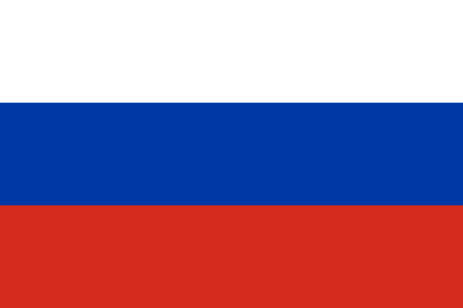
A state symbol is a special historically established distinctive sign of a particular state, established by the constitution or special law, embodying its national sovereignty, originality, and sometimes also bearing a certain ideological meaning (state flag, national emblem, national anthem).
The Russian flag has three equal horizontal fields with white at the top, blue in the middle and red at the bottom. Some Russians believe that white stands for generosity, blue for loyalty and red for courage. But there is no official explanation for the meaning of the colors.
The Russian flag first appeared in 1668. It was the symbol of Russia for more than 300 years. August 22, Russia celebrates national Flag Day. For the first time it was hung over the White House in Moscow in 1991.Officially, in 1994, was adopted a decree on the appointment of this festival. When Russian people celebrate their national holidays you can see the national flag in all streets, squares, official buildings, blocks of flats and houses in big cities, small towns and villages.
The Russian coat-of-arms can be described as the eagle carrying a sceptre, the sign of state power, and an orb, the sign of unity. The emblem also includes St George. It is the oldest Russian symbol of love for Motherland. The double-headed eagle is the emblem of Russia. Above the heads there are three crowns. Three crowns is the symbol of sovereignty [ˈsɔvrəntɪ] of the state, equality of the main governmental branches of power – legislative, judicial and executive.
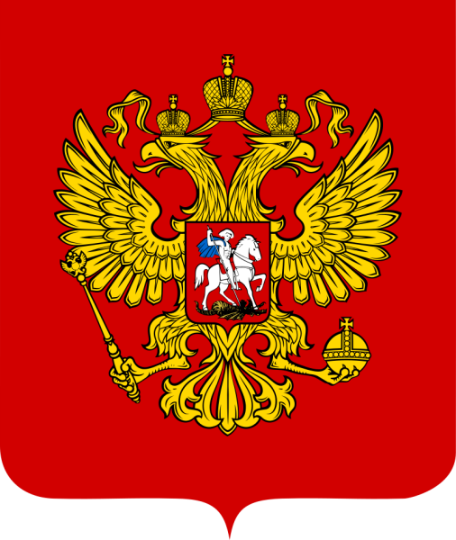
The eagle has long been a symbol of power and dominion. In the Holy Roman Empire’s heraldry, it represented the Church and the State. The coat-of-arms of Russia have gone through three major periods in their history, undergoing major changes in the transitions between the Russian Empire, the Soviet Union, and the Russian Federation.
They date back to 1472, when Ivan III began using the double-headed eagle in his seal, which, along with the image of St. George slaying a dragon, have been common in the coat of arms since. The coat of arms were changed in 1918 with the creation of the Russian Soviet Federative Socialist Republic, and depicted communist symbols such as the hammer and sickle and red star. The current coat-of-arms, in use since 1993, once again uses the double-headed eagle with the image of St. George.
The “State Anthem of the Russian Federation” is the name of the official national anthem of Russia. It uses the same melody as the “State Anthem of the Soviet Union”, composed by Alexander Alexandrov, and new lyrics by Sergey Mikhalkov, who had collaborated with Gabriel El-Registan on the original anthem.
The anthem debate intensified in October 2000 when Yeltsin’s successor, Vladimir Putin, commented that Russian athletes had no words to sing for the anthem during the medal ceremonies at the 2000 Summer Olympic Games. Putin brought public attention to the issue and put it before the State Council.
In a November session of the Federation Council, Putin stated that establishing the national symbols (anthem, flag and coat of arms) should be a top priority for the country. Putin pressed for the former Soviet anthem to be selected as the new Russian anthem, but strongly suggested that new lyrics be written. Putin submitted the bill “On the National Anthem of the Russian Federation” to the Duma for their consideration on 4 December. The Duma voted in favor of adopting Alexandrov’s music as the national anthem on 8 December 2000. Following the vote, a committee was formed and tasked with exploring lyrics for the national anthem. After receiving over 6,000 manuscripts from all sectors of Russian society, the committee selected lyrics by Mikhalkov for the anthem.

Vocabulary:
historically established distinctive sign – исторически принятый отличительный знак  embodying – прич. к to embody – воплощать, олицетворять  bearing – прич. к to bear – нести  a certain ideological meaning – определенная идеологическая нагрузка  equal – равный  field – поле (в разных значениях)  generosity – великодушие, благородство  loyalty – верность, преданность  courage – смелость, храбрость  to be hung over – быть вывешенным  decree – декрет, постановление  coat-of-arms – герб  sceptre – скипетр  orb – держава  sovereignty – независимость, суверенитет  equality – равенство  dominion – владычество, власть  heraldry – геральдика  undergoing major changes – прич. к to | undergo – испытывать, переносить, проходить через (выражение целиком – проходя через главные изменения)  seal – ист. государственная печать  slaying – прич. к to slay – книжн. убивать, уничтожать, лишать жизни (slay-slew-slain)  to depict – изображать  hammer and sickle – серп и молот  to collaborate – работать совместно, сотрудничать  to intensify – усиливать  successor – преемник  to bring public attention to the issue – привлекать общественное внимание к проблеме  a top priority – главный приоритет  to press for – добиваться  to submit the bill – представить на рассмотрение (закон)  consideration – обсуждение, рассмотрение  to vote in favor – проголосовать за  manuscripts – рукописи

Exercise 1. Check yourself answering the following questions:
1. What are the state symbols of the Russian Federation?
2. What is the state flag? What do colours of it (red, white and blue) mean?
3. What do three crowns of Russian coat of arm mean?
4. What does St. George on the breast of eagle mean?
5. What does the scepter mean?
6. What does the orb mean?
7. Who is the author of the state anthem of the Russian Federation?

