Задание по английскому языку для группы 36 на25 апреля.
Выполнить 25 апреля к 16.00
1.В 1 задании подчеркнуть предлоги и сделать перевод
предложений
2.Во 2 задании поставить нужный предлог и перевести
Предложения
Circle the preposition and draw a line under the object of
the preposition.
- You play a violin with a bow.
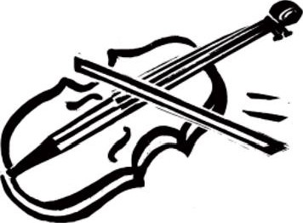
- A violin bow is made of horsehair.
- Excellent violins are made by skilled craftspeople.
- Violinists adjust the bow for a good tone.
- The violin rests on the player's shoulder.
Complete each sentence by adding a prepositional phrase. Use the word or words parentheses ( ) in the phrase.
- We go(concert)
Prepositional
Phrases
Lesson 6
- The high school band plays (school)
- Please do not talk (performance)
- The trumpet player sits (saxophone play
- The musicians warm up (show)
- We return to our seats (intermission)
- I take violin lessons(neighbor)
- Music classes take place(community cent
- You can practice(room)

